**Dog and Cat Classification using CNN**

Create a directory hierarchy same as follow

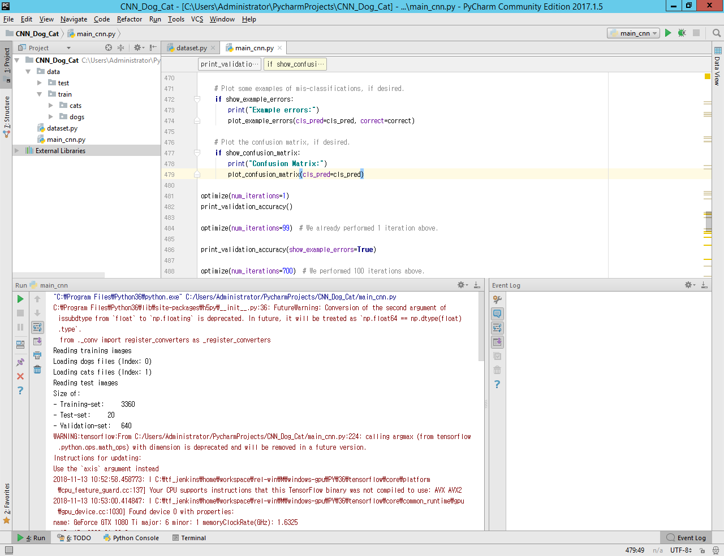

Test folder contains test image, while train folder contains subfolder cats which containing cat images and dogs folder containing dog images for training.

1. **Datasets, save the following code to *dataset.py***
2. Importing some packages

|  |
| --- |
| **import** os **import** glob **import** numpy **as** np **import** cv2 **from** sklearn.utils **import** shuffle |

1. Load training data

|  |
| --- |
| **def** load_train(train_path, image_size, classes):  images = []  labels = []  ids = []  cls = []   print(**'Reading training images'**)  **for** fld **in** classes: *# assuming data directory has a separate folder for each class, and that each folder is named after the class* index = classes.index(fld)  print(**'Loading {} files (Index: {})'**.format(fld, index))  path = os.path.join(train_path, fld, **'*g'**)  files = glob.glob(path)  **for** fl **in** files:  image = cv2.imread(fl)  image = cv2.resize(image, (image_size, image_size), cv2.INTER_LINEAR)  images.append(image)  label = np.zeros(len(classes))  label[index] = 1.0  labels.append(label)  flbase = os.path.basename(fl)  ids.append(flbase)  cls.append(fld)  images = np.array(images)  labels = np.array(labels)  ids = np.array(ids)  cls = np.array(cls)   **return** images, labels, ids, cls |

1. Load testing data

|  |
| --- |
| **def** load_test(test_path, image_size):  path = os.path.join(test_path, **'*g'**)  files = sorted(glob.glob(path))   X_test = []  X_test_id = []  print(**"Reading test images"**)  **for** fl **in** files:  flbase = os.path.basename(fl)  img = cv2.imread(fl)  img = cv2.resize(img, (image_size, image_size), cv2.INTER_LINEAR)  X_test.append(img)  X_test_id.append(flbase)   *### because we're not creating a DataSet object for the test images, normalization happens here* X_test = np.array(X_test, dtype=np.uint8)  X_test = X_test.astype(**'float32'**)  X_test = X_test / 255   **return** X_test, X_test_id |

1. Class data set

|  |
| --- |
| **class** DataSet(object):   **def** __init__(self, images, labels, ids, cls):  *"""Construct a DataSet. one_hot arg is used only if fake_data is true."""* self._num_examples = images.shape[0]    *# Convert shape from [num examples, rows, columns, depth]  # to [num examples, rows*columns] (assuming depth == 1)  # Convert from [0, 255] -> [0.0, 1.0].* images = images.astype(np.float32)  images = np.multiply(images, 1.0 / 255.0)   self._images = images  self._labels = labels  self._ids = ids  self._cls = cls  self._epochs_completed = 0  self._index_in_epoch = 0   @property  **def** images(self):  **return** self._images   @property  **def** labels(self):  **return** self._labels   @property  **def** ids(self):  **return** self._ids   @property  **def** cls(self):  **return** self._cls   @property  **def** num_examples(self):  **return** self._num_examples   @property  **def** epochs_completed(self):  **return** self._epochs_completed |

|  |
| --- |
| **def** next_batch(self, batch_size):  *"""Return the next `batch_size` examples from this data set."""* start = self._index_in_epoch  self._index_in_epoch += batch_size   **if** self._index_in_epoch > self._num_examples:  *# Finished epoch* self._epochs_completed += 1   *# # Shuffle the data (maybe)  # perm = np.arange(self._num_examples)  # np.random.shuffle(perm)  # self._images = self._images[perm]  # self._labels = self._labels[perm]  # Start next epoch* start = 0  self._index_in_epoch = batch_size  **assert** batch_size <= self._num_examples  end = self._index_in_epoch   **return** self._images[start:end], self._labels[start:end], self._ids[start:end], self._cls[start:end] |

1. Read train dataset

|  |
| --- |
| **def** read_train_sets(train_path, image_size, classes, validation_size=0):  **class** DataSets(object):  **pass** data_sets = DataSets()   images, labels, ids, cls = load_train(train_path, image_size, classes)  images, labels, ids, cls = shuffle(images, labels, ids, cls) *# shuffle the data* **if** isinstance(validation_size, float):  validation_size = int(validation_size * images.shape[0])   validation_images = images[:validation_size]  validation_labels = labels[:validation_size]  validation_ids = ids[:validation_size]  validation_cls = cls[:validation_size]   train_images = images[validation_size:]  train_labels = labels[validation_size:]  train_ids = ids[validation_size:]  train_cls = cls[validation_size:]   data_sets.train = DataSet(train_images, train_labels, train_ids, train_cls)  data_sets.valid = DataSet(validation_images, validation_labels, validation_ids, validation_cls)   **return** data_sets |

1. Read test dataset

|  |
| --- |
| **def** read_test_set(test_path, image_size):  images, ids = load_test(test_path, image_size)  **return** images, ids |

1. **Main class, save the following codes to *main_cnn.py***
2. Importing some packages

|  |
| --- |
| **import** time **import** math **import** random  **import** pandas **as** pd **import** numpy **as** np **import** matplotlib.pyplot **as** plt **import** tensorflow **as** tf **import** dataset **import** cv2  **from** sklearn.metrics **import** confusion_matrix **from** datetime **import** timedelta |

1. Configuration hyper parameters

|  |
| --- |
| *# Convolutional Layer 1.* filter_size1 = 3 num_filters1 = 32  *# Convolutional Layer 2.* filter_size2 = 3 num_filters2 = 32  *# Convolutional Layer 3.* filter_size3 = 3 num_filters3 = 64  *# Fully-connected layer.* fc_size = 128 *# Number of neurons in fully-connected layer.  # Number of color channels for the images: 1 channel for gray-scale.* num_channels = 3  *# image dimensions (only squares for now)* img_size = 128  *# Size of image when flattened to a single dimension* img_size_flat = img_size * img_size * num_channels  *# Tuple with height and width of images used to reshape arrays.* img_shape = (img_size, img_size)  *# class info* classes = [**'dogs'**, **'cats'**] num_classes = len(classes)  *# batch size* batch_size = 16  *# validation split* validation_size = .16  *# how long to wait after validation loss stops improving before terminating training* early_stopping = **None** *# use None if you don't want to implement early stoping* train_path = **'data/train/'** test_path = **'data/test/'** checkpoint_dir = **"models/"** |

1. Load data and print data

|  |
| --- |
| data = dataset.read_train_sets(train_path, img_size, classes, validation_size=validation_size) test_images, test_ids = dataset.read_test_set(test_path, img_size)  print(**"Size of:"**) print(**"- Training-set:\t\t{}"**.format(len(data.train.labels))) print(**"- Test-set:\t\t{}"**.format(len(test_images))) print(**"- Validation-set:\t{}"**.format(len(data.valid.labels))) |

1. Function for plotting image

|  |
| --- |
| **def** plot_images(images, cls_true, cls_pred=**None**):  **if** len(images) == 0:  print(**"no images to show"**)  **return  else**:  random_indices = random.sample(range(len(images)), min(len(images), 9))   images, cls_true = zip(*[(images[i], cls_true[i]) **for** i **in** random_indices])   *# Create figure with 3x3 sub-plots.* fig, axes = plt.subplots(3, 3)  fig.subplots_adjust(hspace=0.3, wspace=0.3)   **for** i, ax **in** enumerate(axes.flat):  *# Plot image.* ax.imshow(images[i].reshape(img_size, img_size, num_channels))   *# Show true and predicted classes.* **if** cls_pred **is None**:  xlabel = **"True: {0}"**.format(cls_true[i])  **else**:  xlabel = **"True: {0}, Pred: {1}"**.format(cls_true[i], cls_pred[i])   *# Show the classes as the label on the x-axis.* ax.set_xlabel(xlabel)   *# Remove ticks from the plot.* ax.set_xticks([])  ax.set_yticks([])   *# Ensure the plot is shown correctly with multiple plots  # in a single Notebook cell.* plt.show() |

1. Plot a few images to see if data is correct or not

|  |
| --- |
| *# Get some random images and their labels from the train set.* images, cls_true = data.train.images, data.train.cls  *# Plot the images and labels using our helper-function above.* plot_images(images=images, cls_true=cls_true) |

Output

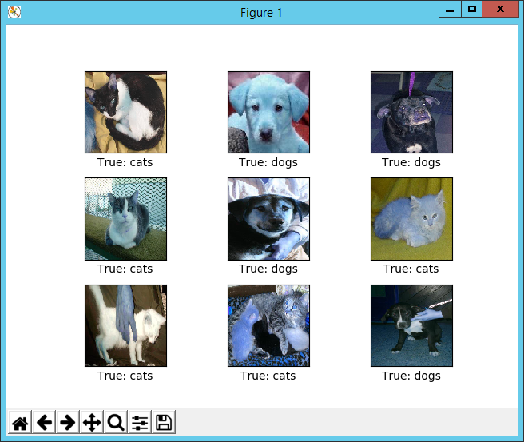

1. Function for creating new variables weights and bias

|  |
| --- |
| **def** new_weights(shape):  **return** tf.Variable(tf.truncated_normal(shape, stddev=0.05))  **def** new_biases(length):  **return** tf.Variable(tf.constant(0.05, shape=[length])) |

1. Function for creating a new convolutional layer

|  |
| --- |
| **def** new_conv_layer(input, *# The previous layer.* num_input_channels, *# Num. channels in prev. layer.* filter_size, *# Width and height of each filter.* num_filters, *# Number of filters.* use_pooling=**True**): *# Use 2x2 max-pooling.   # Shape of the filter-weights for the convolution.  # This format is determined by the TensorFlow API.* shape = [filter_size, filter_size, num_input_channels, num_filters]   *# Create new weights aka. filters with the given shape.* weights = new_weights(shape=shape)   *# Create new biases, one for each filter.* biases = new_biases(length=num_filters)   *# Create the TensorFlow operation for convolution.  # Note the strides are set to 1 in all dimensions.  # The first and last stride must always be 1,  # because the first is for the image-number and  # the last is for the input-channel.  # But e.g. strides=[1, 2, 2, 1] would mean that the filter  # is moved 2 pixels across the x- and y-axis of the image.  # The padding is set to 'SAME' which means the input image  # is padded with zeroes so the size of the output is the same.* layer = tf.nn.conv2d(input=input,  filter=weights,  strides=[1, 1, 1, 1],  padding=**'SAME'**)   *# Add the biases to the results of the convolution.  # A bias-value is added to each filter-channel.* layer += biases   *# Use pooling to down-sample the image resolution?* **if** use_pooling:  *# This is 2x2 max-pooling, which means that we  # consider 2x2 windows and select the largest value  # in each window. Then we move 2 pixels to the next window.* layer = tf.nn.max_pool(value=layer,  ksize=[1, 2, 2, 1],  strides=[1, 2, 2, 1],  padding=**'SAME'**)   *# Rectified Linear Unit (ReLU).  # It calculates max(x, 0) for each input pixel x.  # This adds some non-linearity to the formula and allows us  # to learn more complicated functions.* layer = tf.nn.relu(layer)   *# Note that ReLU is normally executed before the pooling,  # but since relu(max_pool(x)) == max_pool(relu(x)) we can  # save 75% of the relu-operations by max-pooling first.   # We return both the resulting layer and the filter-weights  # because we will plot the weights later.* **return** layer, weights |

1. Function flattened layer

|  |
| --- |
| **def** flatten_layer(layer):  *# Get the shape of the input layer.* layer_shape = layer.get_shape()   *# The shape of the input layer is assumed to be:  # layer_shape == [num_images, img_height, img_width, num_channels]   # The number of features is: img_height * img_width * num_channels  # We can use a function from TensorFlow to calculate this.* num_features = layer_shape[1:4].num_elements()   *# Reshape the layer to [num_images, num_features].  # Note that we just set the size of the second dimension  # to num_features and the size of the first dimension to -1  # which means the size in that dimension is calculated  # so the total size of the tensor is unchanged from the reshaping.* layer_flat = tf.reshape(layer, [-1, num_features])   *# The shape of the flattened layer is now:  # [num_images, img_height * img_width * num_channels]   # Return both the flattened layer and the number of features.* **return** layer_flat, num_features |

1. Function for fully connected layer

|  |
| --- |
| **def** new_fc_layer(input, *# The previous layer.* num_inputs, *# Num. inputs from prev. layer.* num_outputs, *# Num. outputs.* use_relu=**True**): *# Use Rectified Linear Unit (ReLU)?   # Create new weights and biases.* weights = new_weights(shape=[num_inputs, num_outputs])  biases = new_biases(length=num_outputs)   *# Calculate the layer as the matrix multiplication of  # the input and weights, and then add the bias-values.* layer = tf.matmul(input, weights) + biases   *# Use ReLU?* **if** use_relu:  layer = tf.nn.relu(layer)   **return** layer |

1. Place holder variables

|  |
| --- |
| x = tf.placeholder(tf.float32, shape=[**None**, img_size_flat], name=**'x'**)  x_image = tf.reshape(x, [-1, img_size, img_size, num_channels])  y_true = tf.placeholder(tf.float32, shape=[**None**, num_classes], name=**'y_true'**)  y_true_cls = tf.argmax(y_true, dimension=1) |

1. Create Convolution layer 1

|  |
| --- |
| layer_conv1, weights_conv1 = \  new_conv_layer(input=x_image,  num_input_channels=num_channels,  filter_size=filter_size1,  num_filters=num_filters1,  use_pooling=**True**) |

1. Create Convolution layer 2

|  |
| --- |
| layer_conv2, weights_conv2 = \  new_conv_layer(input=layer_conv1,  num_input_channels=num_filters1,  filter_size=filter_size2,  num_filters=num_filters2,  use_pooling=**True**) |

1. Create Convolution layer 3

|  |
| --- |
| layer_conv3, weights_conv3 = \  new_conv_layer(input=layer_conv2,  num_input_channels=num_filters2,  filter_size=filter_size3,  num_filters=num_filters3,  use_pooling=**True**) |

1. Create flattened layer

|  |
| --- |
| layer_flat, num_features = flatten_layer(layer_conv3) |

1. Create fully connected layer 1

|  |
| --- |
| layer_fc1 = new_fc_layer(input=layer_flat,  num_inputs=num_features,  num_outputs=fc_size,  use_relu=**True**) |

1. Create fully connected layer 2

|  |
| --- |
| layer_fc2 = new_fc_layer(input=layer_fc1,  num_inputs=fc_size,  num_outputs=num_classes,  use_relu=**False**) |

1. Predicted class

|  |
| --- |
| y_pred = tf.nn.softmax(layer_fc2)  y_pred_cls = tf.argmax(y_pred, dimension=1) #the class number is the index of largest element |

1. Cost function to be optimized

|  |
| --- |
| cross_entropy = tf.nn.softmax_cross_entropy_with_logits(logits=layer_fc2,  labels=y_true) cost = tf.reduce_mean(cross_entropy) |

1. Optimization method

|  |
| --- |
| optimizer = tf.train.AdamOptimizer(learning_rate=1e-4).minimize(cost)  correct_prediction = tf.equal(y_pred_cls, y_true_cls)  accuracy = tf.reduce_mean(tf.cast(correct_prediction, tf.float32)) |

1. Tensorflow Run

|  |
| --- |
| session = tf.Session()  session.run(tf.initialize_all_variables())  train_batch_size = batch_size |

1. Function to perform optimization iterations

|  |
| --- |
| **def** print_progress(epoch, feed_dict_train, feed_dict_validate, val_loss):  *# Calculate the accuracy on the training-set.* acc = session.run(accuracy, feed_dict=feed_dict_train)  val_acc = session.run(accuracy, feed_dict=feed_dict_validate)  msg = **"Epoch {0} --- Training Accuracy: {1:>6.1%}, Validation Accuracy: {2:>6.1%}, Validation Loss: {3:.3f}"** print(msg.format(epoch + 1, acc, val_acc, val_loss)) |

1. Counter for total number of iterations performed so far

|  |
| --- |
| total_iterations = 0  **def** optimize(num_iterations):  *# Ensure we update the global variable rather than a local copy.* **global** total_iterations   *# Start-time used for printing time-usage below.* start_time = time.time()   best_val_loss = float(**"inf"**)  patience = 0   **for** i **in** range(total_iterations,  total_iterations + num_iterations):   *# Get a batch of training examples.  # x_batch now holds a batch of images and  # y_true_batch are the true labels for those images.* x_batch, y_true_batch, _, cls_batch = data.train.next_batch(train_batch_size)  x_valid_batch, y_valid_batch, _, valid_cls_batch = data.valid.next_batch(train_batch_size)   *# Convert shape from [num examples, rows, columns, depth]  # to [num examples, flattened image shape]* x_batch = x_batch.reshape(train_batch_size, img_size_flat)  x_valid_batch = x_valid_batch.reshape(train_batch_size, img_size_flat)   *# Put the batch into a dict with the proper names  # for placeholder variables in the TensorFlow graph.* feed_dict_train = {x: x_batch,  y_true: y_true_batch}   feed_dict_validate = {x: x_valid_batch,  y_true: y_valid_batch}   *# Run the optimizer using this batch of training data.  # TensorFlow assigns the variables in feed_dict_train  # to the placeholder variables and then runs the optimizer.* session.run(optimizer, feed_dict=feed_dict_train)   *# Print status at end of each epoch (defined as full pass through training dataset).* **if** i % int(data.train.num_examples / batch_size) == 0:  val_loss = session.run(cost, feed_dict=feed_dict_validate)  epoch = int(i / int(data.train.num_examples / batch_size))   print_progress(epoch, feed_dict_train, feed_dict_validate, val_loss)   **if** early_stopping:  **if** val_loss < best_val_loss:  best_val_loss = val_loss  patience = 0  **else**:  patience += 1   **if** patience == early_stopping:  **break** *# Update the total number of iterations performed.* total_iterations += num_iterations   *# Ending time.* end_time = time.time()   *# Difference between start and end-times.* time_dif = end_time - start_time   *# Print the time-usage.* print(**"Time elapsed: "** + str(timedelta(seconds=int(round(time_dif))))) |

1. Function to plot example errors

|  |
| --- |
| **def** plot_example_errors(cls_pred, correct):  *# cls_pred is an array of the predicted class-number for  # all images in the test-set.   # correct is a boolean array whether the predicted class  # is equal to the true class for each image in the test-set.   # Negate the boolean array.* incorrect = (correct == **False**)   *# Get the images from the test-set that have been  # incorrectly classified.* images = data.valid.images[incorrect]   *# Get the predicted classes for those images.* cls_pred = cls_pred[incorrect]   *# Get the true classes for those images.* cls_true = data.valid.cls[incorrect]   *# Plot the first 9 images.* plot_images(images=images[0:9],  cls_true=cls_true[0:9],  cls_pred=cls_pred[0:9]) |

1. Function to plot confusion matrix

|  |
| --- |
| **def** plot_confusion_matrix(cls_pred):  *# cls_pred is an array of the predicted class-number for  # all images in the test-set.   # Get the true classifications for the test-set.* cls_true = data.valid.cls   *# Get the confusion matrix using sklearn.* cm = confusion_matrix(y_true=cls_true,  y_pred=cls_pred)   *# Print the confusion matrix as text.* print(cm)   *# Plot the confusion matrix as an image.* plt.matshow(cm)   *# Make various adjustments to the plot.* plt.colorbar()  tick_marks = np.arange(num_classes)  plt.xticks(tick_marks, range(num_classes))  plt.yticks(tick_marks, range(num_classes))  plt.xlabel(**'Predicted'**)  plt.ylabel(**'True'**)   *# Ensure the plot is shown correctly with multiple plots  # in a single Notebook cell.* plt.show() |

1. Function for showing the performance

|  |
| --- |
| **def** print_validation_accuracy(show_example_errors=**False**,  show_confusion_matrix=**False**):  *# Number of images in the test-set.* num_test = len(data.valid.images)   *# Allocate an array for the predicted classes which  # will be calculated in batches and filled into this array.* cls_pred = np.zeros(shape=num_test, dtype=np.int)   *# Now calculate the predicted classes for the batches.  # We will just iterate through all the batches.  # There might be a more clever and Pythonic way of doing this.   # The starting index for the next batch is denoted i.* i = 0   **while** i < num_test:  *# The ending index for the next batch is denoted j.* j = min(i + batch_size, num_test)   *# Get the images from the test-set between index i and j.* images = data.valid.images[i:j, :].reshape(batch_size, img_size_flat)   *# Get the associated labels.* labels = data.valid.labels[i:j, :]   *# Create a feed-dict with these images and labels.* feed_dict = {x: images,  y_true: labels}   *# Calculate the predicted class using TensorFlow.* cls_pred[i:j] = session.run(y_pred_cls, feed_dict=feed_dict)   *# Set the start-index for the next batch to the  # end-index of the current batch.* i = j   cls_true = np.array(data.valid.cls)  cls_pred = np.array([classes[x] **for** x **in** cls_pred])   *# Create a boolean array whether each image is correctly classified.* correct = (cls_true == cls_pred)   *# Calculate the number of correctly classified images.  # When summing a boolean array, False means 0 and True means 1.* correct_sum = correct.sum()   *# Classification accuracy is the number of correctly classified  # images divided by the total number of images in the test-set.* acc = float(correct_sum) / num_test   *# Print the accuracy.* msg = **"Accuracy on Test-Set: {0:.1%} ({1} / {2})"** print(msg.format(acc, correct_sum, num_test))   *# Plot some examples of mis-classifications, if desired.* **if** show_example_errors:  print(**"Example errors:"**)  plot_example_errors(cls_pred=cls_pred, correct=correct)   *# Plot the confusion matrix, if desired.* **if** show_confusion_matrix:  print(**"Confusion Matrix:"**)  plot_confusion_matrix(cls_pred=cls_pred) |

1. Performance after 1 optimization iteration

|  |
| --- |
| optimize(num_iterations=1) print_validation_accuracy() |

Output

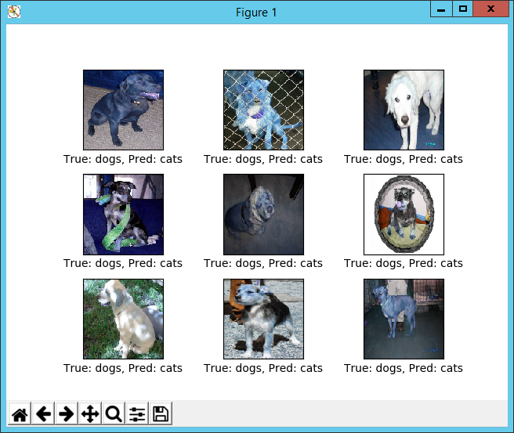

1. Performance after 100 optimization iterations

|  |
| --- |
| optimize(num_iterations=100) *# We already performed 1 iteration above.* print_validation_accuracy(show_example_errors=**True**) |

Output

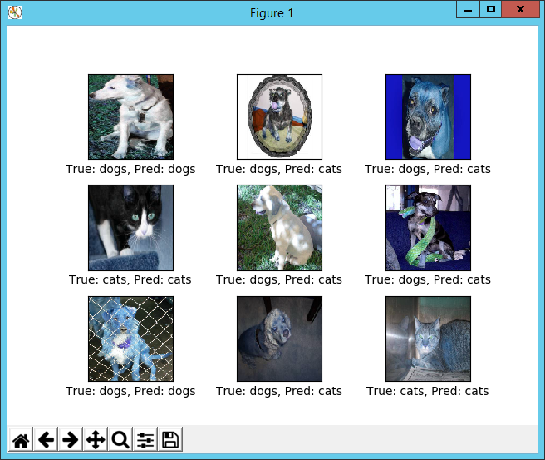

1. Performance after 500 optimization iterations

|  |
| --- |
| optimize(num_iterations=500) *# We already performed 1 iteration above.* print_validation_accuracy(show_example_errors=**True**) |

Output

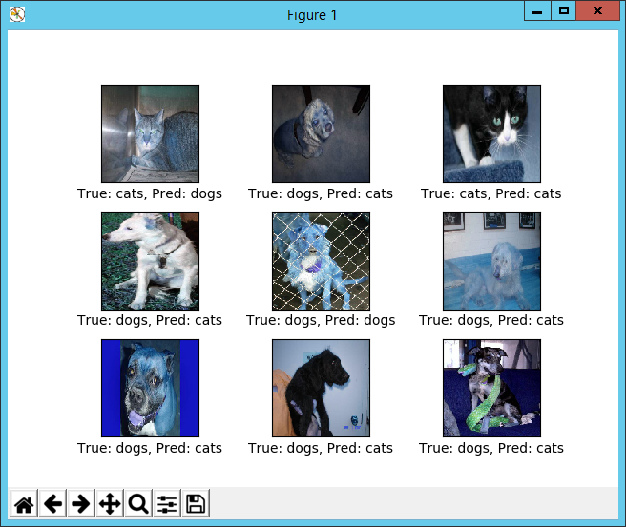

1. Performance after 1000 optimization iterations

|  |
| --- |
| optimize(num_iterations=1000) *# We performed 1000 iterations above.* print_validation_accuracy(show_example_errors=**True**, show_confusion_matrix=**True**) |

1. Test on sample image

|  |
| --- |
| plt.axis(**'off'**)  test_cat = cv2.imread(**'data/test/1.jpg'**) test_cat = cv2.resize(test_cat, (img_size, img_size), cv2.INTER_LINEAR) / 255  preview_cat = plt.imshow(test_cat.reshape(img_size, img_size, num_channels))  test_dog = cv2.imread(**'data/test/12500.jpg'**) test_dog = cv2.resize(test_dog, (img_size, img_size), cv2.INTER_LINEAR) / 255  preview_dog = plt.imshow(test_dog.reshape(img_size, img_size, num_channels))   **def** sample_prediction(test_im):  feed_dict_test = {  x: test_im.reshape(1, img_size_flat),  y_true: np.array([[1, 0]])  }   test_pred = session.run(y_pred_cls, feed_dict=feed_dict_test)  **return** classes[test_pred[0]]   print(**"Predicted class for test_cat: {}"**.format(sample_prediction(test_cat))) print(**"Predicted class for test_dog: {}"**.format(sample_prediction(test_dog))) |

1. Function for plotting convolution weight

|  |
| --- |
| **def** plot_conv_weights(weights, input_channel=0):  *# Assume weights are TensorFlow ops for 4-dim variables  # e.g. weights_conv1 or weights_conv2.   # Retrieve the values of the weight-variables from TensorFlow.  # A feed-dict is not necessary because nothing is calculated.* w = session.run(weights)   *# Get the lowest and highest values for the weights.  # This is used to correct the colour intensity across  # the images so they can be compared with each other.* w_min = np.min(w)  w_max = np.max(w)   *# Number of filters used in the conv. layer.* num_filters = w.shape[3]   *# Number of grids to plot.  # Rounded-up, square-root of the number of filters.* num_grids = math.ceil(math.sqrt(num_filters))   *# Create figure with a grid of sub-plots.* fig, axes = plt.subplots(num_grids, num_grids)   *# Plot all the filter-weights.* **for** i, ax **in** enumerate(axes.flat):  *# Only plot the valid filter-weights.* **if** i < num_filters:  *# Get the weights for the i'th filter of the input channel.  # See new_conv_layer() for details on the format  # of this 4-dim tensor.* img = w[:, :, input_channel, i]   *# Plot image.* ax.imshow(img, vmin=w_min, vmax=w_max,  interpolation=**'nearest'**, cmap=**'seismic'**)   *# Remove ticks from the plot.* ax.set_xticks([])  ax.set_yticks([])   *# Ensure the plot is shown correctly with multiple plots  # in a single Notebook cell.* plt.show() |

1. Function for plot convolutional layer

|  |
| --- |
| **def** plot_conv_layer(layer, image):  *# Assume layer is a TensorFlow op that outputs a 4-dim tensor  # which is the output of a convolutional layer,  # e.g. layer_conv1 or layer_conv2.* image = image.reshape(img_size_flat)   *# Create a feed-dict containing just one image.  # Note that we don't need to feed y_true because it is  # not used in this calculation.* feed_dict = {x: [image]}   *# Calculate and retrieve the output values of the layer  # when inputting that image.* values = session.run(layer, feed_dict=feed_dict)   *# Number of filters used in the conv. layer.* num_filters = values.shape[3]   *# Number of grids to plot.  # Rounded-up, square-root of the number of filters.* num_grids = math.ceil(math.sqrt(num_filters))   *# Create figure with a grid of sub-plots.* fig, axes = plt.subplots(num_grids, num_grids)   *# Plot the output images of all the filters.* **for** i, ax **in** enumerate(axes.flat):  *# Only plot the images for valid filters.* **if** i < num_filters:  *# Get the output image of using the i'th filter.  # See new_conv_layer() for details on the format  # of this 4-dim tensor.* img = values[0, :, :, i]   *# Plot image.* ax.imshow(img, interpolation=**'nearest'**, cmap=**'binary'**)   *# Remove ticks from the plot.* ax.set_xticks([])  ax.set_yticks([])   *# Ensure the plot is shown correctly with multiple plots  # in a single Notebook cell.* plt.show() |

1. Test the image

|  |
| --- |
| **def** plot_image(image):  plt.imshow(image.reshape(img_size, img_size, num_channels),  interpolation=**'nearest'**)  plt.show() |

|  |
| --- |
| image1 = test_images[0] plot_image(image1)  image2 = test_images[9] plot_image(image2)  plot_conv_weights(weights=weights_conv1)  plot_conv_layer(layer=layer_conv1, image=image1)  plot_conv_layer(layer=layer_conv1, image=image2)  plot_conv_weights(weights=weights_conv2, input_channel=0)  plot_conv_weights(weights=weights_conv2, input_channel=1)  plot_conv_layer(layer=layer_conv2, image=image1)  plot_conv_layer(layer=layer_conv2, image=image2) |

1. Predict all the test data and write the result in csv

|  |
| --- |
| **def** write_predictions(ims, ids):  ims = ims.reshape(ims.shape[0], img_size_flat)  preds = session.run(y_pred, feed_dict={x: ims})  result = pd.DataFrame(preds, columns=classes)  result.loc[:, **'id'**] = pd.Series(ids, index=result.index)  pred_file = **'predictions.csv'** result.to_csv(pred_file, index=**False**)   write_predictions(test_images, test_ids) |

**Console ouput**

